

Europass  Curriculum Vitae |  | 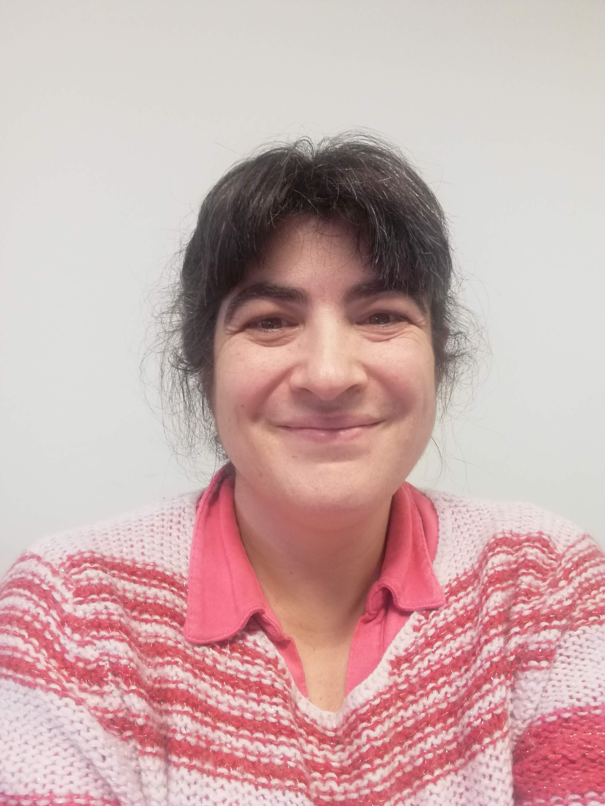
Personal information
First name(s) / Surname(s) |  | Elisa Marraccini
Address |  | Via Delle Scienze 206, 33100 Udine
Telephone |  | +39 0432 558614
E-mail |  | elisa.marraccini@uniud.it
Date of birth |  | 12/03/1980
Work experience
Dates |  | 10/2021 – ongoing
Institution |  | University of Udine, Italy
SSD  Role |  | AGR-02  Associate professor
Dates |  | 09/2014 – 08/2021
Institution |  | Institut Polytechnique UniLaSalle, Beauvais, France
SSD  Role |  | AGR-02  Associate professor
Dates |  | 03/2014 – 08/2014
Institution |  | Scuola Superiore Sant’Anna, Pisa, Italy
SSD  Role |  | AGR-02  Assistant professor
Dates |  | 09/2013 – 12/2013
Institution |  | AgroParisTech, Clermont-Ferrand, France
SSD  Role |  | AGR-02  Research assistant
Dates |  | 10/2012 – 03/2013
Institution |  | INRA, Clermont-Ferrand, France
SSD  Role |  | AGR-02  Research assistant
Dates |  | 04/2009 – 01/2010
Institution |  | Scuola Superiore Sant’Anna, Pisa, Italy
SSD  Role |  | AGR-02  Research assistant
Education and training
Date |  | 2010
Title of qualification awarded |  | PhD in Agricultural and Environmental Sciences, Scuola Superiore Sant’Anna, Pisa (I),  AgroParisTech Paris (F)
PhD thesis title |  | Assessment of agro-environmental functions - a landscape agronomy approach
Date |  | 2005
Title of qualification awarded |  | Degree in Agricultural Sciences, Scuola Superiore Sant’Anna, Pisa (I)
Degree thesis title |  | Analysis of the land use of a polyculture-oriented agricultural region (Puy-de-Daume) and of its impact on agricultural multifunctionality
Date |  | 2004
Title of qualification awarded |  | MSc in Agricultural Sciences and Technologies, University of Pisa (I)
MSc thesis title |  | An analysis of water use in the nursery flowers farms of Pistoia.
Personal skills and competences
Mother tongues |  | Italian / French
Other language(s)
Self-assessment |  |  | Understanding |  |  |  |  | Speaking |  |  |  |  | Writing
European level (*) |  |  | Listening |  | Reading |  |  | Spoken interaction |  | Spoken production
English |  |  | B2 | Indipendent user | C1 | Proficient user |  | B2 | Indipendent user | B1 |  | Indipendent user | B1 | Indipendent user
Spanish |  |  | C1 | Proficient user | C1 | Proficient user |  | B1 | Indipendent user | B1 |  | Indipendent user | A2 | Basic user
 |  | (*) Common European Framework of Reference for Languages
Institutional positions held in university |  | At University of Udine (I)  2021-ongoing: member of the board of the experimental farm A. Servadei  2022-ongoing: coordinator of the BSc in Agricultural Sciences and MSc in Agricultural Sciences and Technologies  At UniLaSalle, Beauvais (F)  2017-2021: Director of the Department of Agricultural Sciences  2015-2019: Co-coordinator of the MSc in Agronomy and Territory
Scientific publications |  | Updated list of scientific publications on Scopus homepage: https://www.scopus.com/authid/detail.uri?authorId=55008938600  ORCID 0000-0002-2797-0758
Research projects and groups |  | 2021-ongoing Member of the research group in Crop science and biotechnology at the University of Udine (I)  2023-2025: ECO-DRESS (ECOsystem services enhancement in DiveRsifiEd Soybean-based Systems) project – Italian PRIN, deputy-coordinator. More information: https://ecodress.uniud.it/  2023-2025: LEG-ITA (Innovative approaches to determine grain LEGume yield and yield stability in ITAlian cropping systems) project – Italian PRIN, coordinator. More information: https://legita.uniud.it/  2023-2026: SICaNSE (Information System to support ecosystem services related to the agricultural activities in the FVG region) Project – Friuli-Venezia-Giulia region  2022-2025: AGRITECH National Center – Next Generation EU, project coordinator University of Napoli, Spoke coordinator University of Padua. More information: https://agritechcenter.it/  2021-2024: LATEST Project – Erasmus+ Strategic Cooperation partnership, coordinator UniLaSalle (France). More information: https://latest-project.eu/  2014-2021 Member of the INTERACT research team at UniLaSalle, Beauvais (F)  2020-2022: PROVEG (Plant Proteins) Project - Normandy region, coordinator UniLaSalle  2020-2022: Soja made in Normandy Project - Normandy region, coordinator University de Caen  2020-2021: RMT Sols et Territoires – French Ministry of Agriculture, coordinator Agricultural Chamber Nouvelle Acquitaine & INRA  2018-2020 : ABC’Terre2 Project – French Environment and Energy Management Agency ADEME, coordinator AgroTransfert-RT  2016-2020: DIVERCROP project - grant agreements n° 219262er (ARIMNet) and n° 618127 (ARIMNet2), coordinator UMR EMMAH, INRA Avignon  2005-2014 Member of the Institute of Life Sciences at Scuola Superiore Sant’Anna, Pisa (I) and of the UMR Metafort, Clermont-Ferrand (F)  2014-2016: Area Pisana research project – Municipality of Pisa  2012-2016: DAUME Project – Systerra call, French National Research Agency n° ANR-2010-STRA-007-01, coordinator UMR Innovation, INRA Montpellier  2012: Agricultural land use patterns in periurban regions. Grant from French Embassy in Italy.  2009-2010: ENDURE NoE – 6th EU Framework Programme, leader INRA Sophia Antipolis (France)
Udine, 4th of January 2025
I authorize the processing of my personal data in accordance with Article 13 of Legislative Decree No. 196 of June 30, 2003 –
“Code regarding the protection of personal data" and Article 13 of the GDPR 679/16 –
“European Regulation on the protection of personal data”

